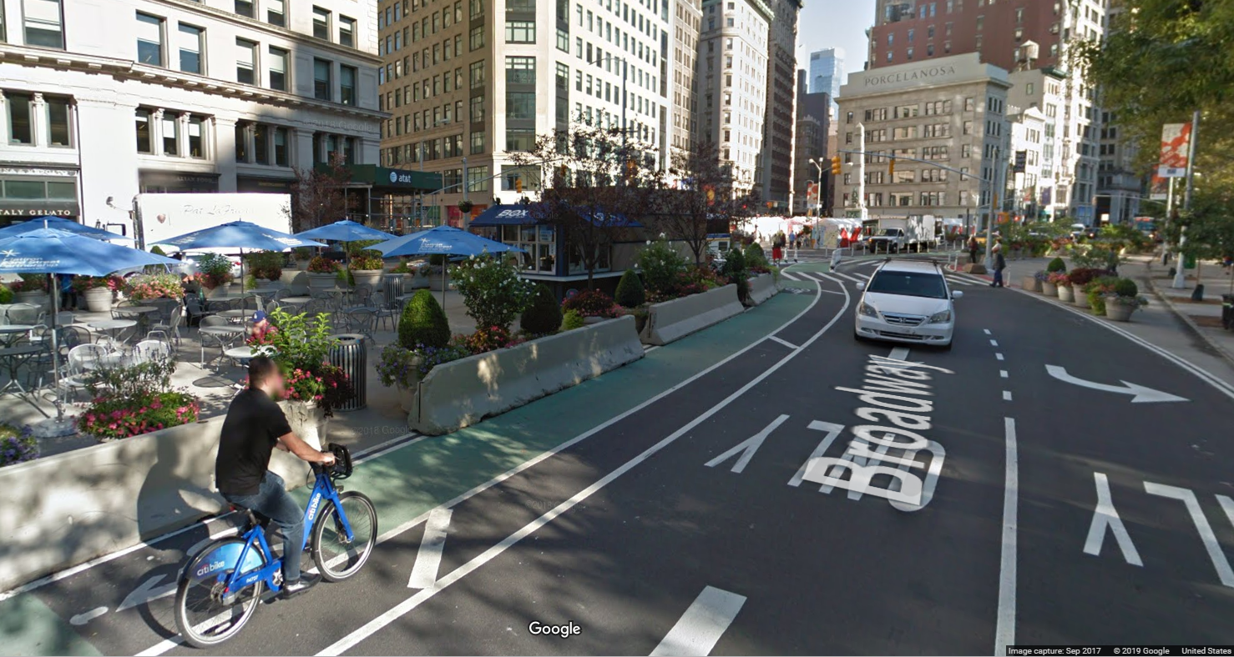

 Rider

Quarterly Report Q1 2019

|  |
| --- |
|  |
|  |
| June 13  Published by:  CitiBike Data Collection Center  NYC Department Of Transportation  Authored by:  Rob Phillips |

# Safe Rider News

|  |
| --- |
| Health and Safety Check Since the publication of [Safer Cycling: Bicycle Ridership and Safety in New York City](http://www.nyc.gov/html/dot/downloads/pdf/bike-safety-study-fullreport2017.pdf) released in 2017, the [NYC DOT](https://www1.nyc.gov/html/dot/html/bicyclists/bicyclists.shtml) continues to evaluate cyclist health and safety data collected by the CitiBike Data Collection Center (DCC).  As we continue to gather more data daily, the CitiBike DCC monitors, analyses and reports key rider health and safety information to NYC Planning and our cyclist community. CitiBike Rider is a quarterly report of these findings, and highlights important information which directly contributes to [Bike Smart](https://www1.nyc.gov/html/dot/html/bicyclists/biketips.shtml) and the [Vision Zero](https://www1.nyc.gov/site/visionzero/index.page) Action Plan. |
| *“The Vision Zero Action Plan is New York City's foundation for ending traffic deaths and injuries on our streets”* |
| Making Data Count  |  | | --- | | CitiBike Trip Data Every time a CitiBike bicycle is rented from a station, some essential data is logged to better inform rider health and safety. This includes the time of day, rider age and gender, station location, duration and distance of each trip. | | *“Every CitiBike Station and bicycle rental provides key data”* |   The true heartbeat of the Big Apple is its people. Each quarter we examine bicycle movements by station and zip code to identify increases in the number of riders. Between 2006 and 2015, the number of cyclist trips increased from 66 million to 164 million. We forecast the number of cyclist trips will exceed 250 million by the year 2025.  This means that our roadways will need to accommodate 150% more cyclist traffic over the next 6 years. This is a significant challenge for one of the largest island cities on the planet, where space is not only vital for the lifestyle for millions of residents, but also highly constrained and precious for their health and wellbeing. |
| Rider Preference  |  |  | | --- | --- | | By The Numbers Whether for exercise, the commute, or leisure, CitiBike Bike Share provides an eco-friendly means of individual transport across NYC. CitiBike riders have already indicated their [Bike Share pass preferences](https://public.tableau.com/profile/robbie.phillips#!/vizhome/PassPurchases2014-2018/PassPurchases?publish=yes) to suit their lifestyle over the past 5 years.    Figure 1: Preference for 7-Day Passes and Annual memberships (bold) diminished with the introduction of 24-Hour and 3-Day Passes   |  | | --- | | Cyclist Demographics As we dig deeper into [Pass Purchases by Gender](https://public.tableau.com/profile/robbie.phillips#!/vizhome/CitiBikeTrips/PassPurchasesByGender?publish=yes), it is evident that the most frequent riders are males making daily trips on a 24-Hour Pass. While the 3-Day Pass have only increased marginally in popularity following discontinuation of the 7-Day Passes in 2016.  A close up of a map  Description automatically generated  Figure 2: The 24-Hour Pass is most popular particularly for male (Gender 1) cyclists.  While protecting the privacy of individual riders, the CitiBike DCC does not collect personal information regarding the purpose of bicycle rentals. It does however, track the miles travelled, the start time and duration of each trip, and the start and end station locations. [From this data](https://public.tableau.com/profile/robbie.phillips#!/vizhome/CitiBikeTrips/MilesTravelledByGender?publish=yes) we are able to determine profiles of bicycle usage, including the total number of miles travelled to date for males, females, and other/non-identified gender.  Comparing the proportion of male to female miles per 24-Hour pass, there is only a 2% difference between the average miles travelled by gender. This means that while males may be the predominant bicycle renters (see Figure 3), the average distance travelled on a 24-Hour pass is quite consistent regardless of gender.    Figure 3: Male cyclists have logged over 15 billion miles more than other genders,  due only to the disproportionate number of male renters.    The Safer Cycling report breaks the female rider data down to Bike Share stations by neighborhood to examine more popular areas for female riders. This earlier analysis identified these areas as less congested and with better connected bicycle facilities.  Smart Moves!  *“Female riders choose less congested neighborhoods with better connected bicycle facilities”* |  Shifting GearsGoing the distance While males continue to predominate the CitiBike trip data year on year, less frequent female riders (Gender 2) are actually riding much longer than the male counterparts, in terms of [trip duration](https://public.tableau.com/profile/robbie.phillips#!/vizhome/AgeGenderTripDuration/AgeGenderTripDuration?publish=yes). This indicates that female riders are either more leisurely or are riding further as exercise, and riders over the age of 50 almost always take their time for either reason.    Figure 4: Younger males travel more frequently and for shorter periods daily,  indicating a common purpose for bicycle rental may be for commuting. | | *“Older riders enjoy longer less frequent trips, while younger riders are riding more frequently for much shorter durations.”* |  In contrast to this observation, younger male riders who start at stations near bridges to Manhattan have longer trip durations than their older male counterparts in the same zip code. The following [map](https://public.tableau.com/profile/robbie.phillips#!/vizhome/CitiBike_MaleDemographic_2016-18/MaleDemographic?publish=yes) depicts the start station locations of male riders by zip code.A close up of a map  Description automatically generatedThis may be indicative that younger riders are travelling longer distances or through more traffic congestion, implying that they are commuting into the city for work each day, via the bridge near to the start station. Unfortunately for this period, not all start times are included in the available data set to identify a correlation with week-day business hours, but end station data is supportive of commuter routes. |
| Contested Routes  |  | | --- | | Competing Demands In consideration of intercity commuting, we took a closer look at one such route, beginning at a start station by the Williamsburg Bridge. The first observation is how scarce CitiBikes are at the inbound station on a weekday. All but two of more than 40 cycles at this station are already in use.    Not surprisingly, the main CitiBike station on W 52nd street by De Witt Clinton Park is also empty, indicating that cycles are in high demand by morning commuters. It already appears that CitiBike may already not be meeting this growing demand.    Safety In Numbers  For every cyclist not using a CitiBike, they are most likely riding their own personal bicycle, adding to the congestion of available bicycle paths across NYC. And while NYC has undergone several development initiatives to improve connected bike networks, just how easy is it for a cyclist to safely maneuver in the Big Apple?  A screenshot of a social media post  Description automatically generatedWith cyclist data indicating a continued upward increase of more than 250 million trips per year by 2025, how do the current routes shape up, and what impact do we foresee on cyclist safety in the future?  According to the Safer Cycling report, there is anticipated safety in numbers. As the number of riders increases, and bike networks expand, the percentage of cyclist injuries and deaths is anticipated to decrease. As part of the Vision Zero program, the NYC DOT is focused on a range of initiatives which improve access to connected cycle facilities, upgrade the existing network of protected bicycle lanes, and expand the network to the outer suburbs where injury rates are currently much higher compared with the inner city neighborhoods. | | *“OneNYC: NYC DOT aims to build 10 lane miles of protected bicycle lanes each year.”* |   Reducing Cyclist KSI  A screenshot of a cell phone  Description automatically generated  The DDC monitors how many cyclists are Killed or Seriously Injured (KSI) per year.  Based on more recent data for 2016 onward, the average cyclist fatalities per year continues to be flat, at around 18 fatalities per year. While average cyclist fatalities per 100 million trips continue to steadily decrease.  The largest challenge is how to control the total number of cyclist injuries per year, considering the volume of riders is rapidly increasing, and bike lane widths continue to be constrained by several competing traffic factors. The reality is that routes are increasingly contested.    A close up of a map  Description automatically generated  Figure 5: Proportionally less cyclist fatalities and injuries per 100 million trips, does not hide the fact that the total number is still increasing year on year. |
| Intersecting ConcernsAt The CrossroadsPlotting [bicycle accident data](https://public.tableau.com/profile/robbie.phillips" \l "!/vizhome/CycleAccidents/CycleAccidents?publish=yes) across Manhattan reveals a striking pattern. At least 89% of all incidents resulting in serious injury to cyclists occur at intersections.A close up of a map  Description automatically generated |

Figure 6: Though not all intersections have recorded accidents involving bicycles each year, there are more recorded accidents than intersections in Downtown Manhattan.

Fatalities as a result of a bicycle colliding with a pedestrian are rare. At least 71% of cyclist fatalities involve the cyclist being stuck by the front of a moving vehicle. The vast majority of cyclist serious injuries are due to a vehicle moving alongside, a right-angle collision, or a vehicle turning in front of the cyclist at an intersection. A significant amount of serious injuries involve a truck or other large vehicle. These concerns remain the focus of the Vision Zero Action Plan.

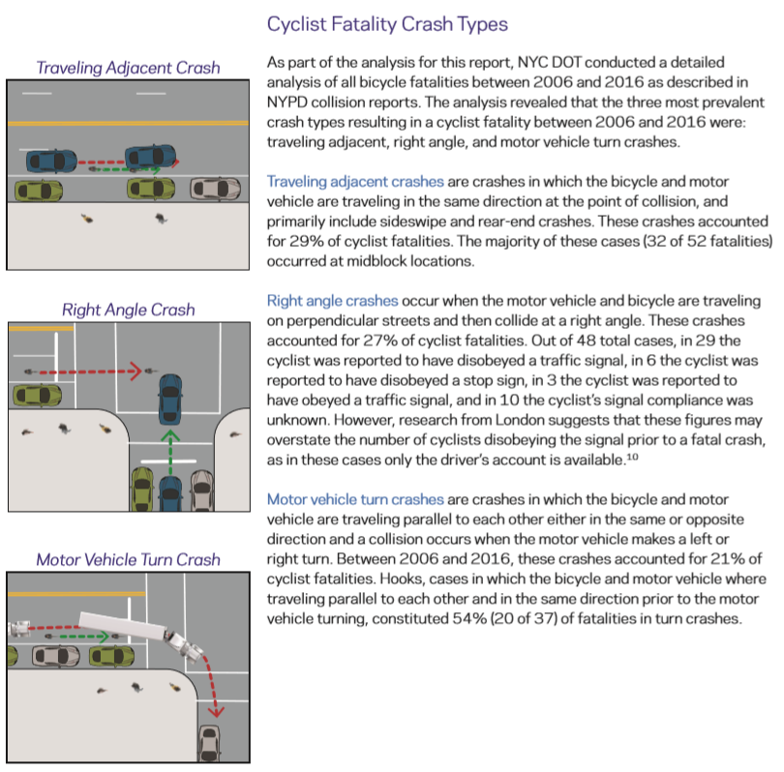

Figure 7: The Safer Cycling report identifies the most prolific crash types resulting in serious injury or death of a cyclist.

## Suffering Adjacencies

The following images depict some of the challenges facing cyclists with respect to significantly constrained routes. Each of these images is a location where an accident involving serious injury of a cyclist has taken place.

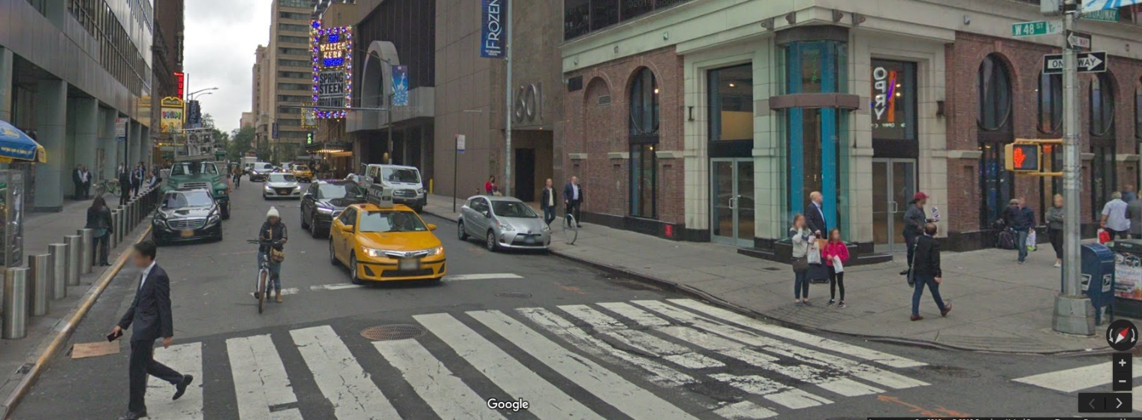

Image: 48th Street and Broadway – no lane markings

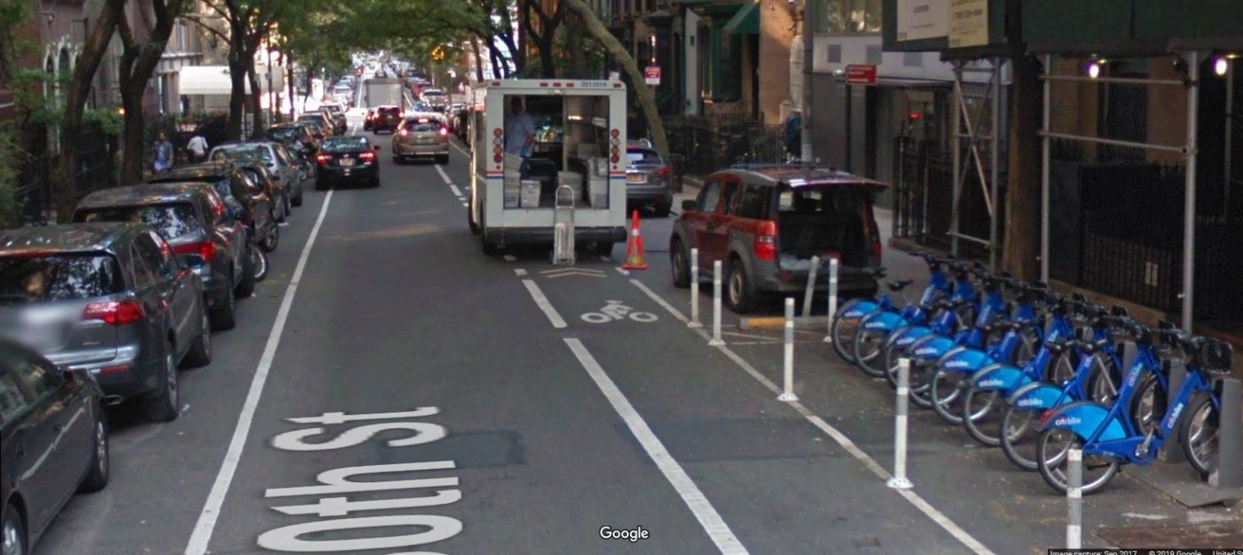

Image: 10th Street and Clifton – obstructed bike lane

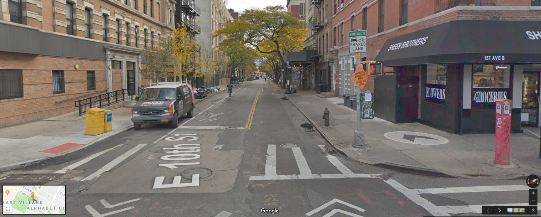

Image: 10th Street and Avenue B – shared lane

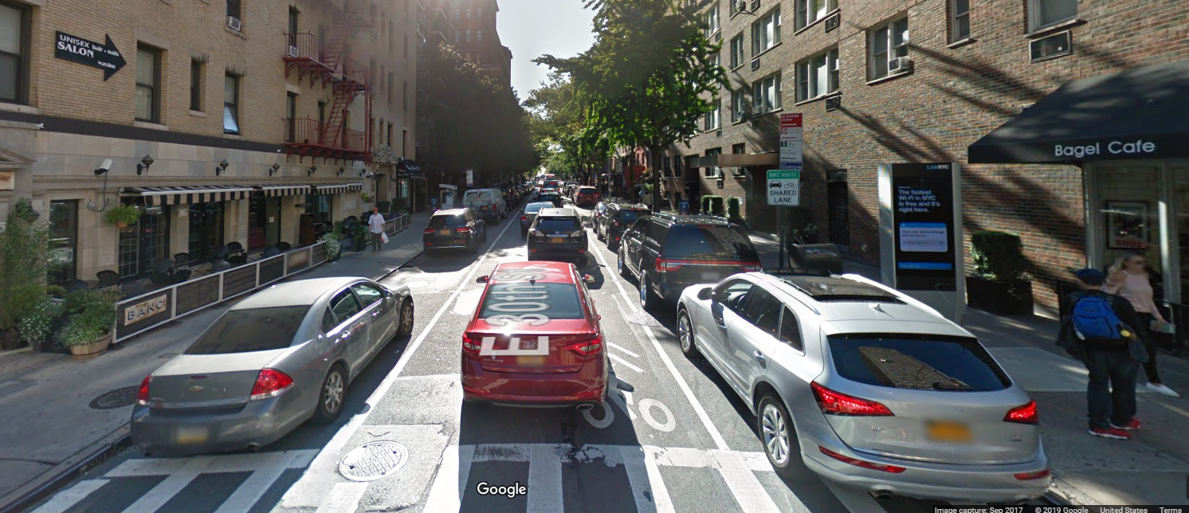

Image: 30th Street and 3rd Avenue – shared lane

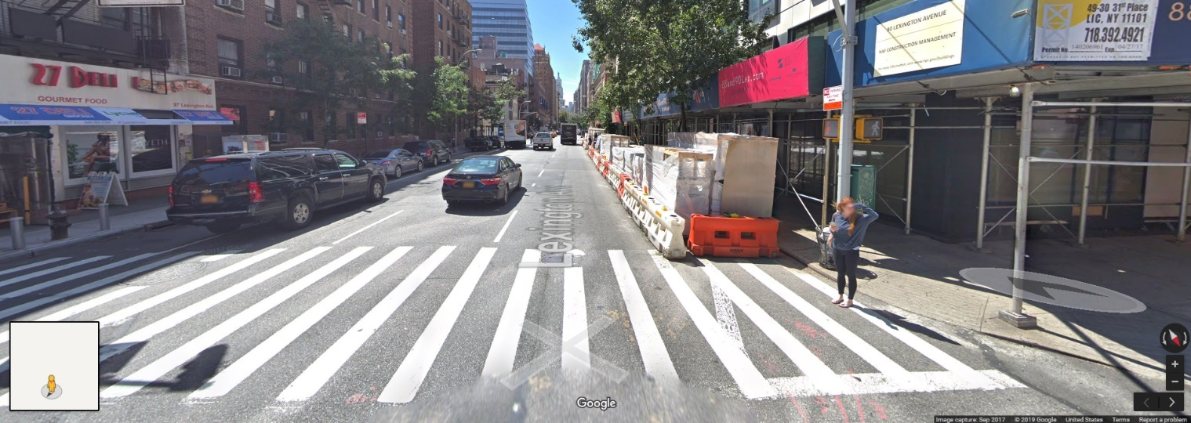

Image: Lexington Avenue – obstructed bike lane

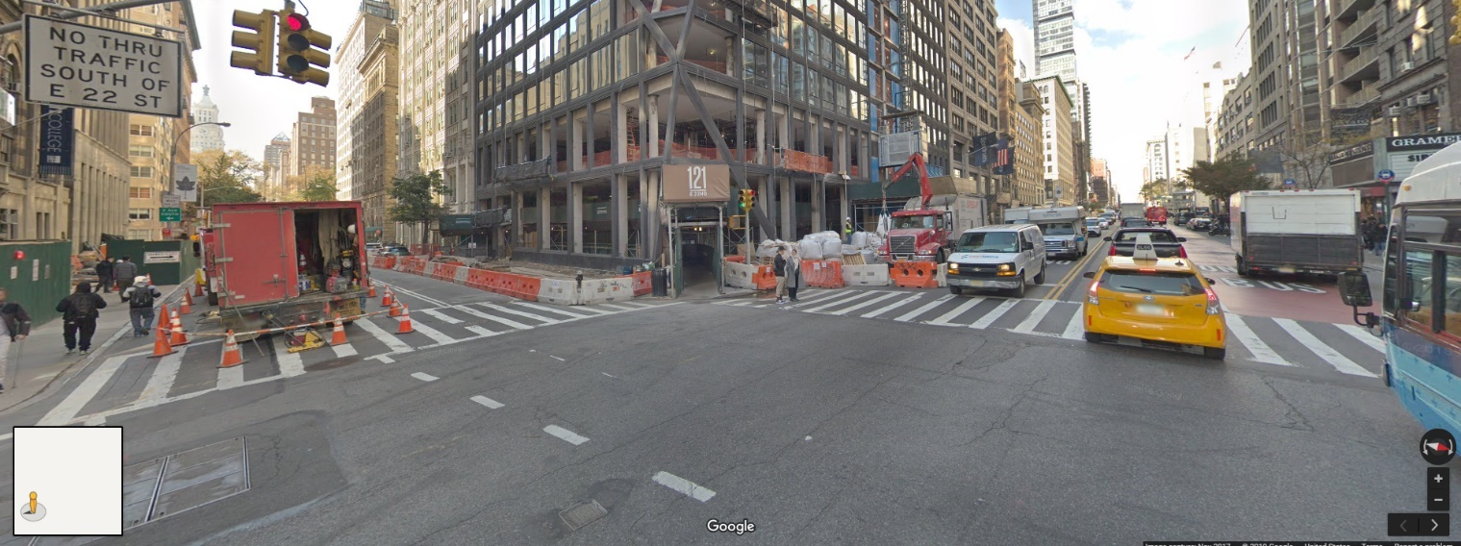

Image: 22nd Street and Lexington Avenue – obstructed bike lanes

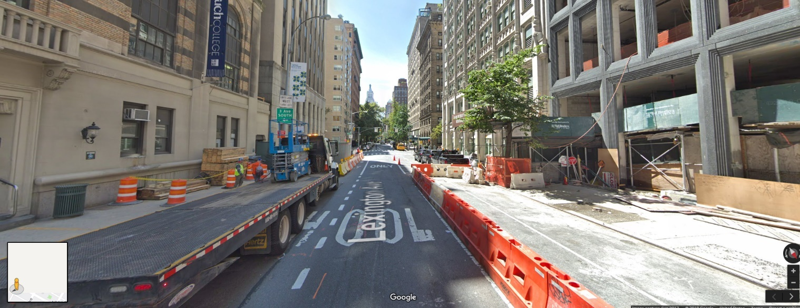

Image: Lexington Avenue – obstructed bike lane

## Right Angle - Wrong Time

The following images depict examples of intersections that submit cyclists to right angle crashes.

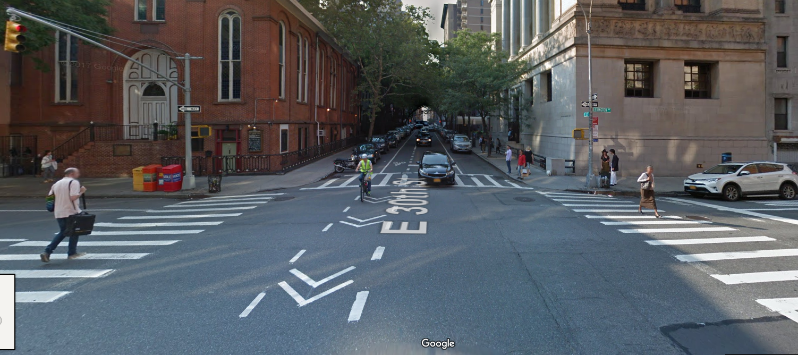

Image: 30th Street and Lexington Avenue – proceed at risk

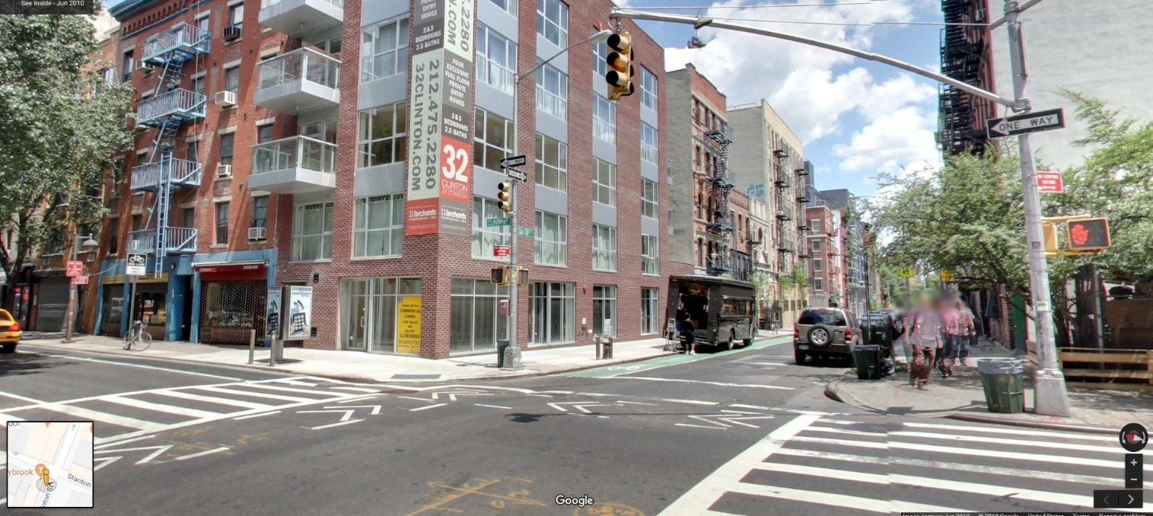

Image: Clinton Street and Stanton Avenue – proceed at risk

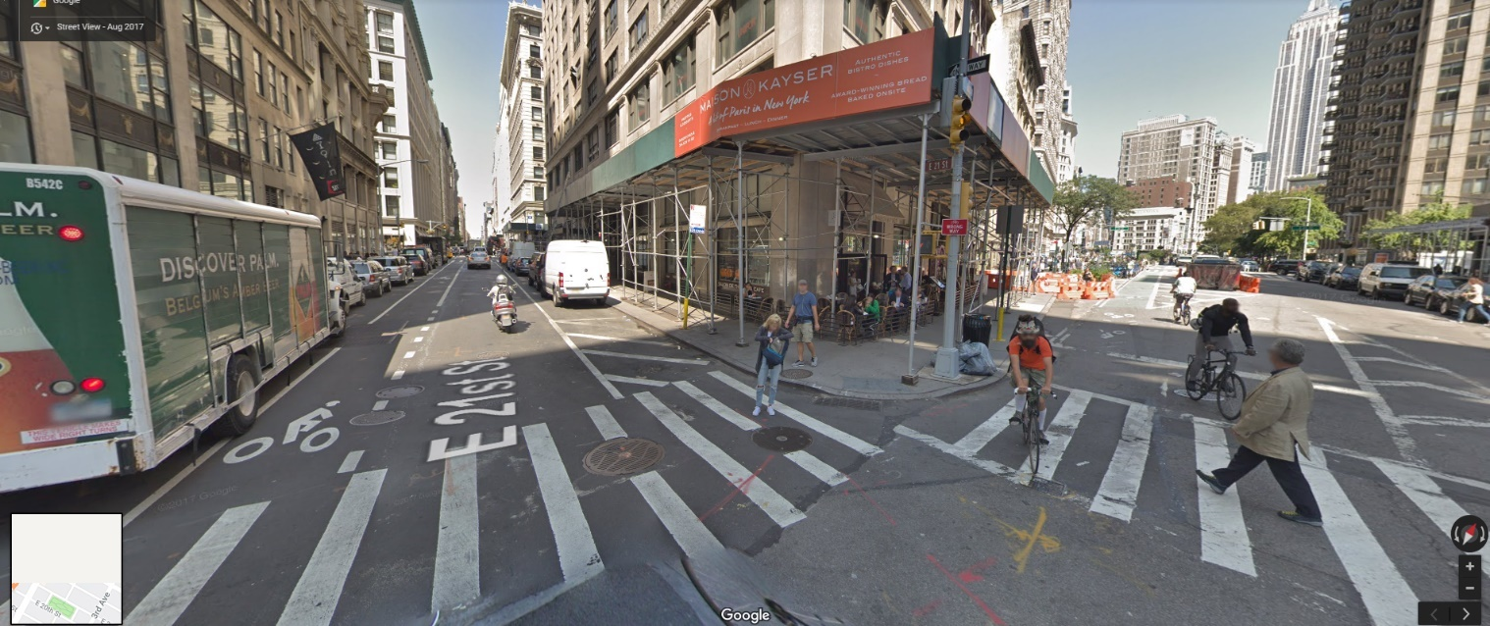

Image: 21st Street and Broadway – proceed at risk

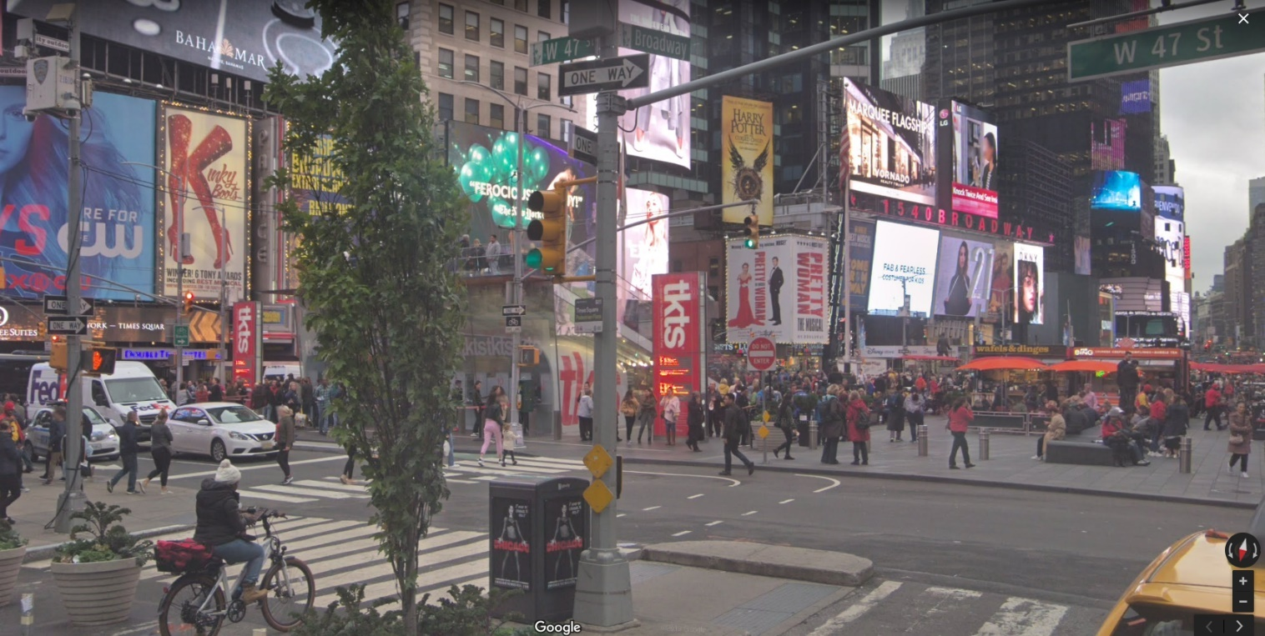

Image: 47th Street and Broadway – proceed at risk

## Turning Hard

The following images depict example intersections where turning crashes have likely occurred, resulting in serious injury or death of cyclists.

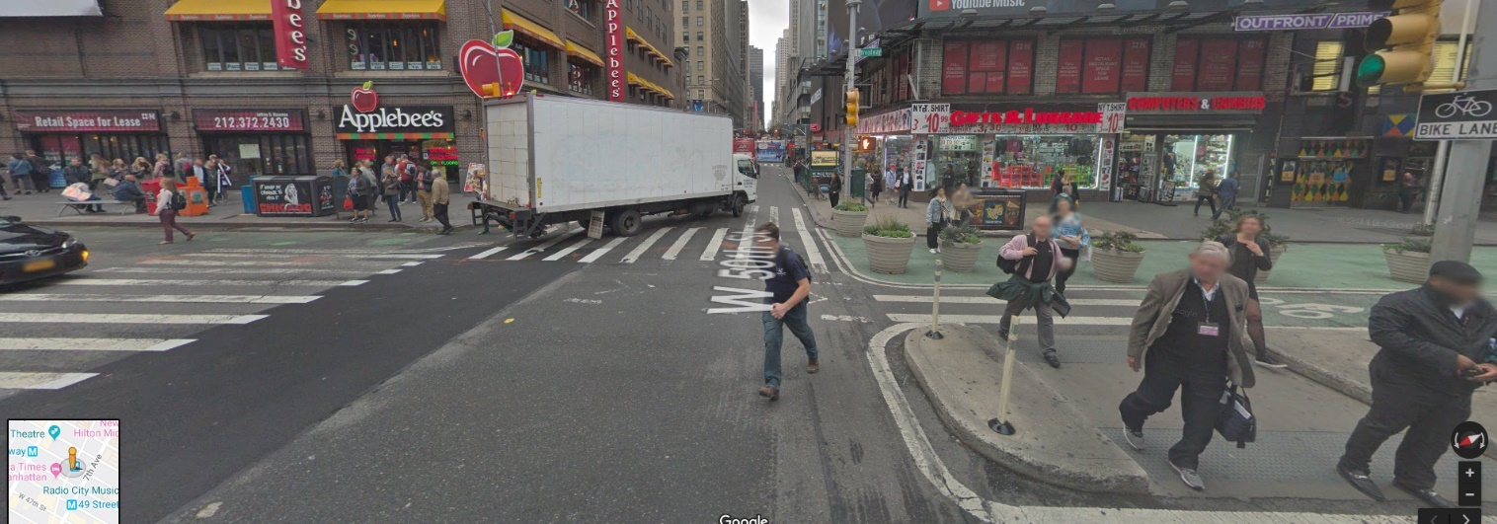

Image: 50th Street and Broadway – turning delivery truck across bike lane

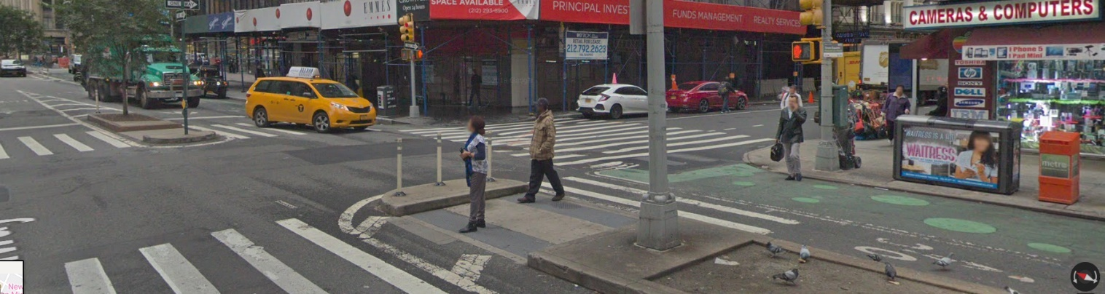

Image: 52nd Street and Broadway – turning concrete truck across bike lane

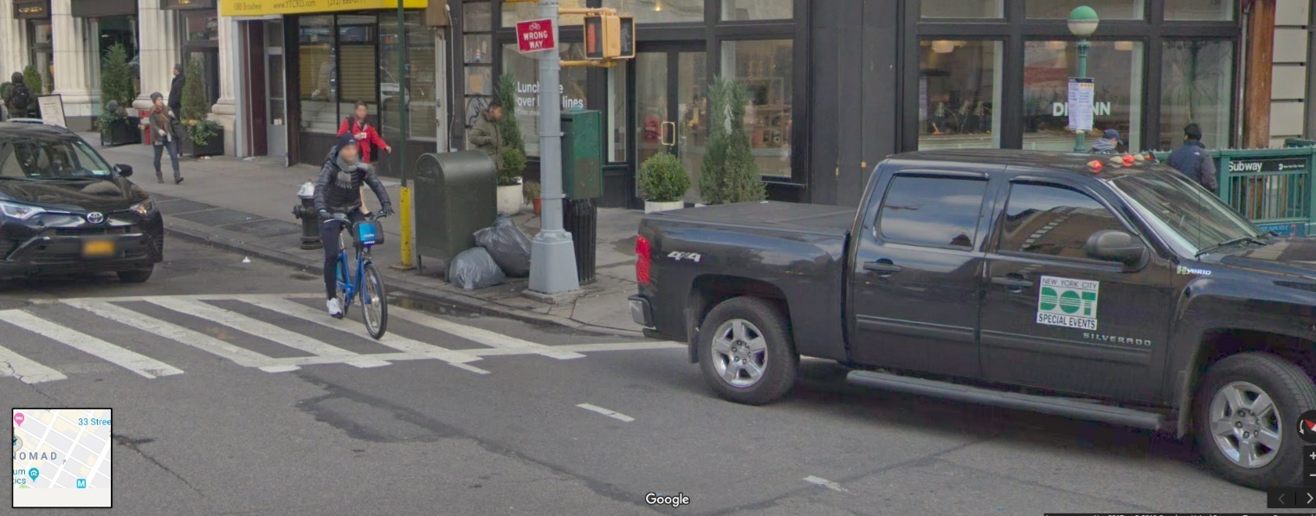

Image: No marked bike lane or marked turning lane

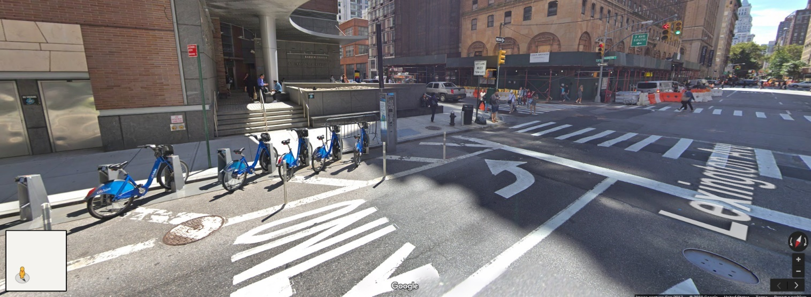

Image: Lexington Avenue – no marked bike lane

Bike Smart attempts to address some of these cyclist risks through safety education.

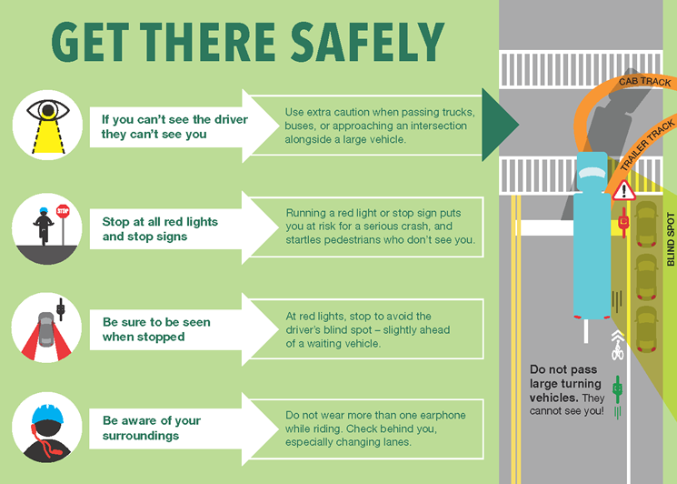

Figure 8: Rider safety awareness training is an essential element of the

Vision Zero Action Plan

# Contributing Factors

## Behind The Wheel

The DDC also compares the [contributing factors](https://public.tableau.com/profile/robbie.phillips#!/vizhome/NYPD_Accident_Data_2014-2019/ContributingFactorsToCyclistAccidents-InjuriesNYC2004-2019?publish=yes) to vehicle accidents involving cyclists, as identified in NYPD accident reports.

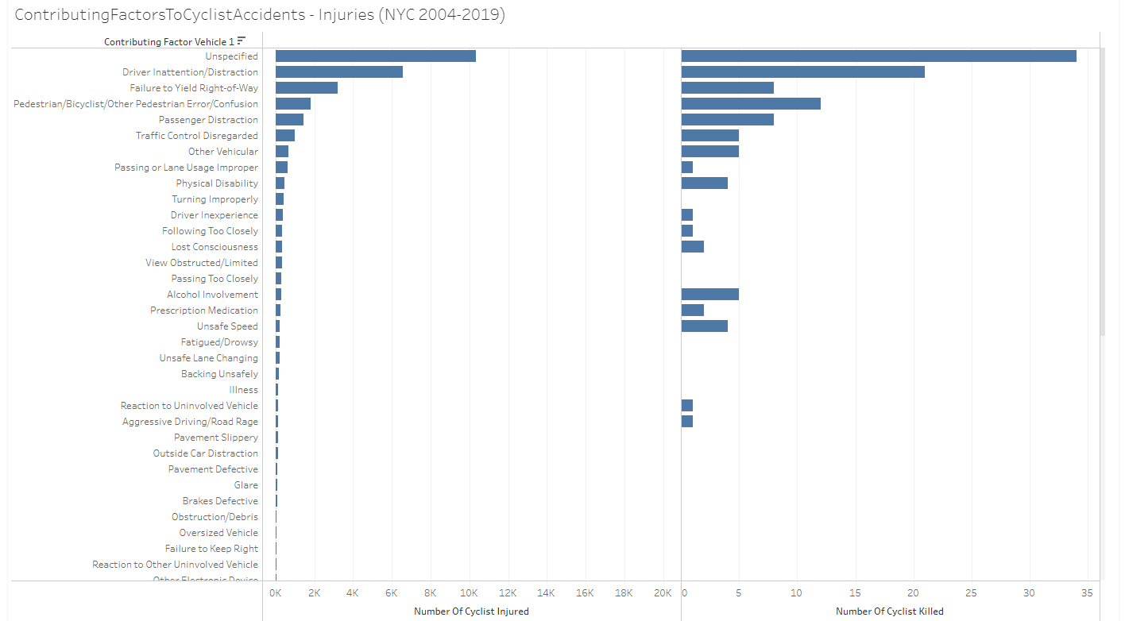

Figure 9: Contributing Factors to Cyclist Accidents involving serious injury and death.

The most significant contributors to serious injury and death of cyclists involving a motor vehicle include driver distraction, confusion, and failure to yield right-of-way. Given the lack of visibility a driver has of a bicycle in its blind spot, many of the unspecified factors most likely relate to adjacent and turning vehicle events where lane space is constrained and the driver may be simply unaware of the bicycle’s proximity.

The DDC has visualized the relative effects of these contributors by [plotting](https://public.tableau.com/profile/robbie.phillips#!/vizhome/ContributingFactorstoKSIbybNYCZipcode/ContributingFactorsToCyclistAccidents-InjuriesbyZipcodeNYC2004-2019?publish=yes) them by zip code. The propensity of these factors resulting in cyclist accidents actually occur within the CitiBike network area already. While at least 25% of accidents still occur outside of the CitiBike network, the cyclists are not immune from driver error.

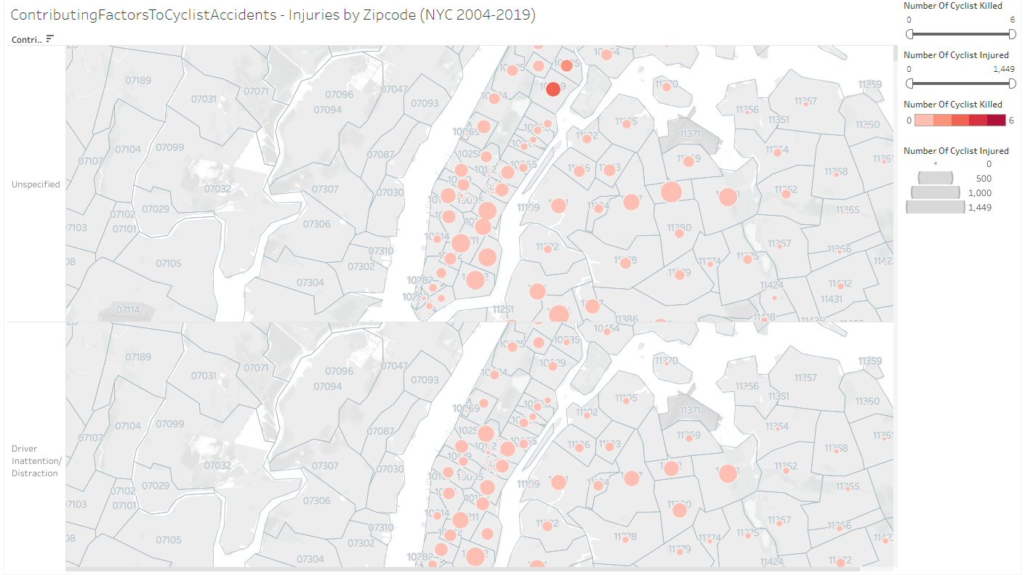

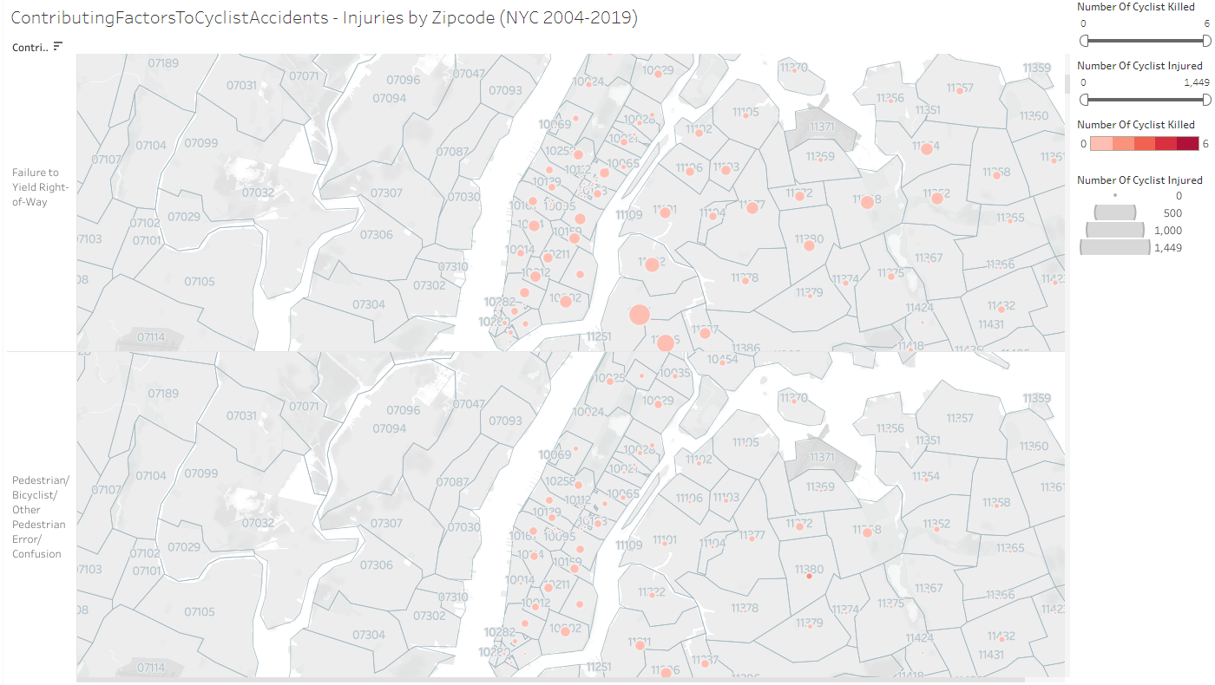

Figure 10: Contributing Factors to Cyclist Accidents by Zip Code.

The significance of these factors extend beyond simply marking bicycle lanes on roadways as a means of ensuring safety. They exemplify a need for more substantial measures, such as increased protected bicycle lanes, truck side guards, safer intersection design, and driver education.

# Smarter City

## Safer Space

The DDC is empowering Vision Zero View, to better visualize and plan for a brighter outlook in NYC. The best way to manage growth in the Big Apple, is using Big Data.

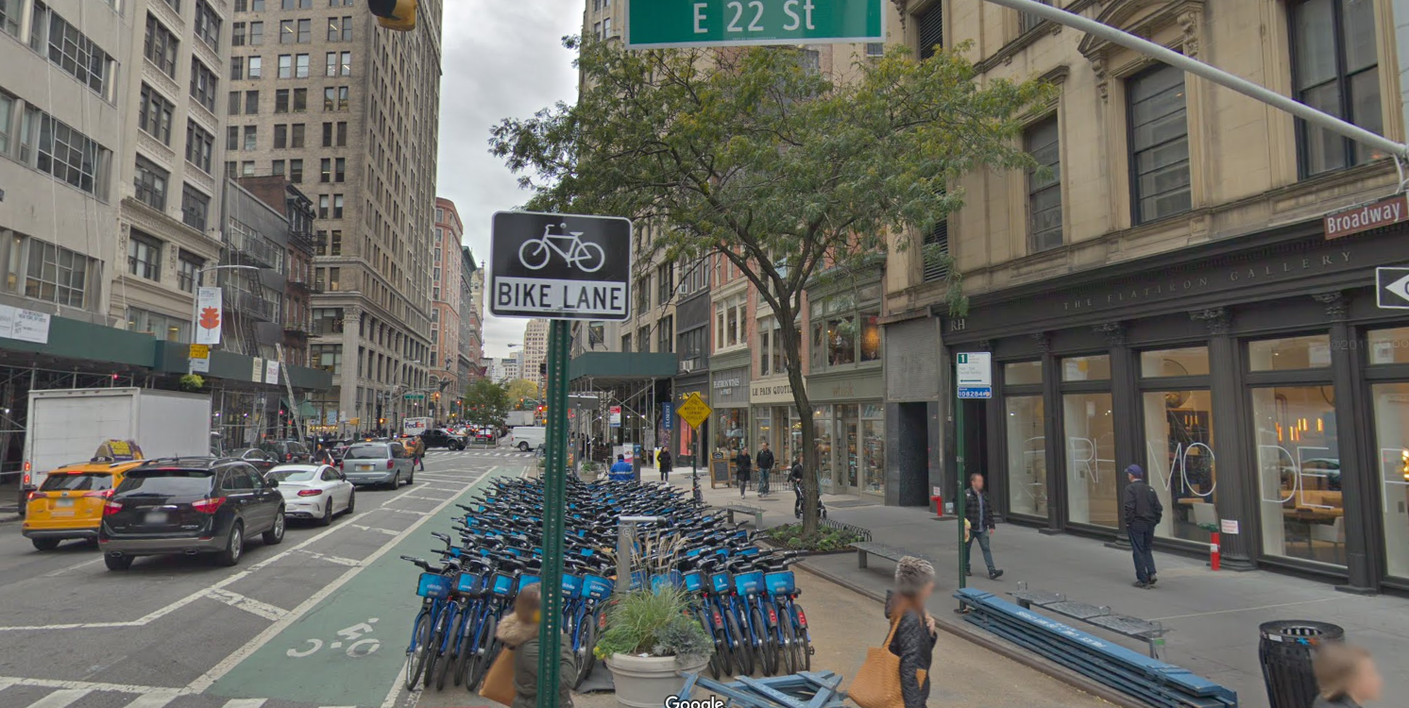

Figure 11: Downtown CitiBike stations show sign of coming increases.

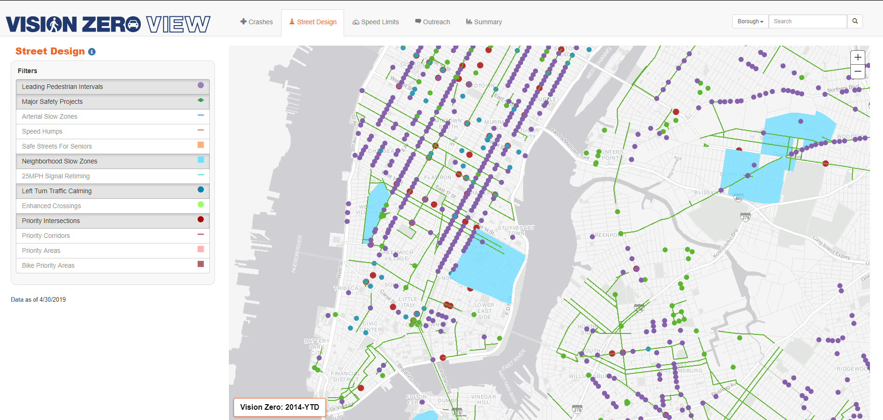

Figure 12: [Vision Zero View](http://www.nycvzv.info/) provides a comprehensive outlook on the Action Plan.

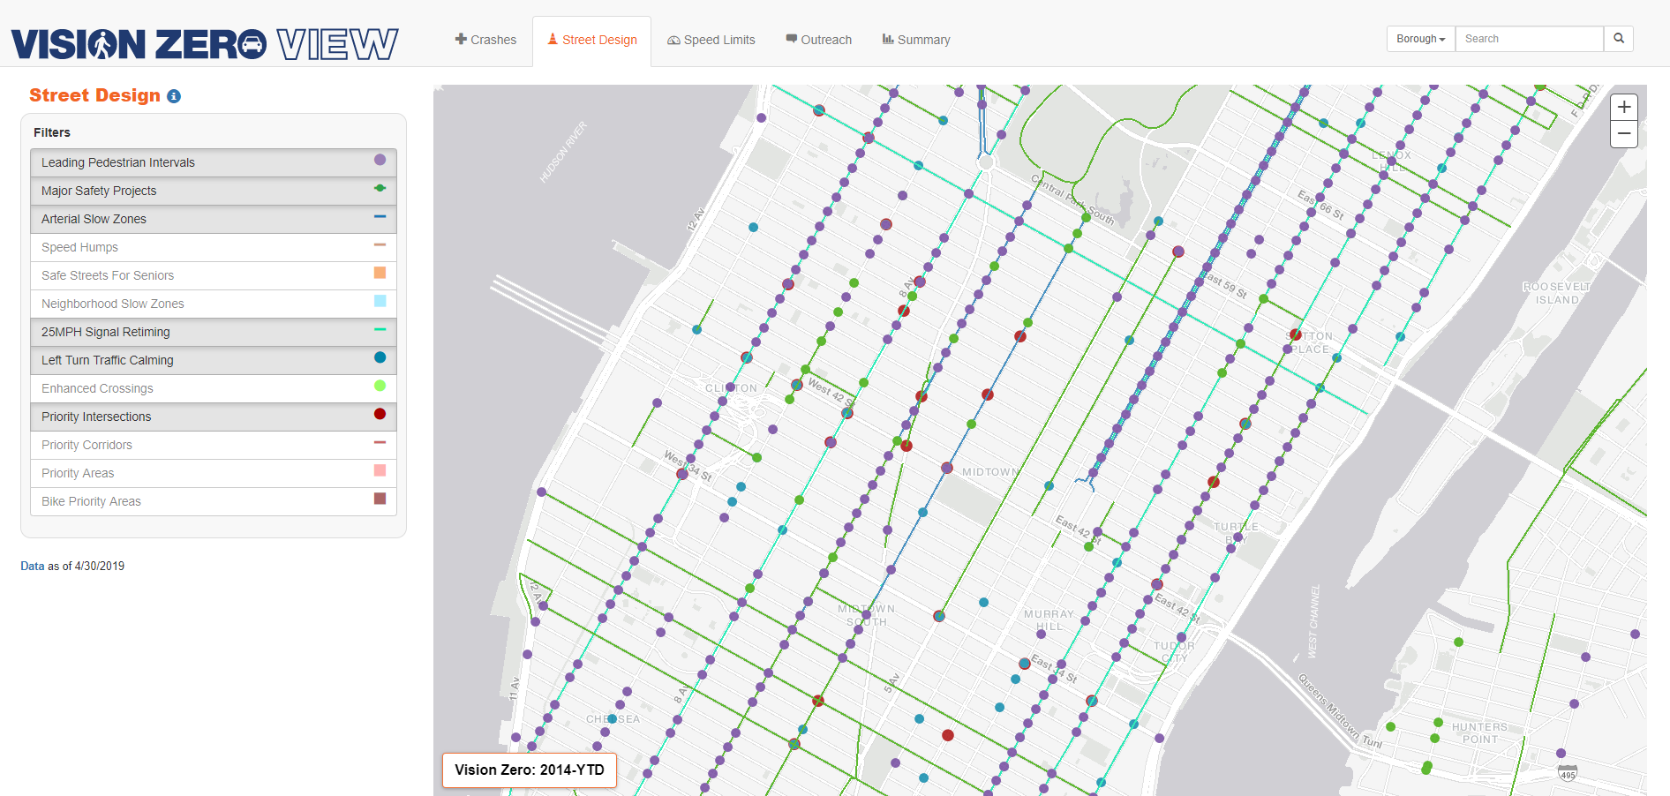

Figure 13: Measurable improvements are data driven.

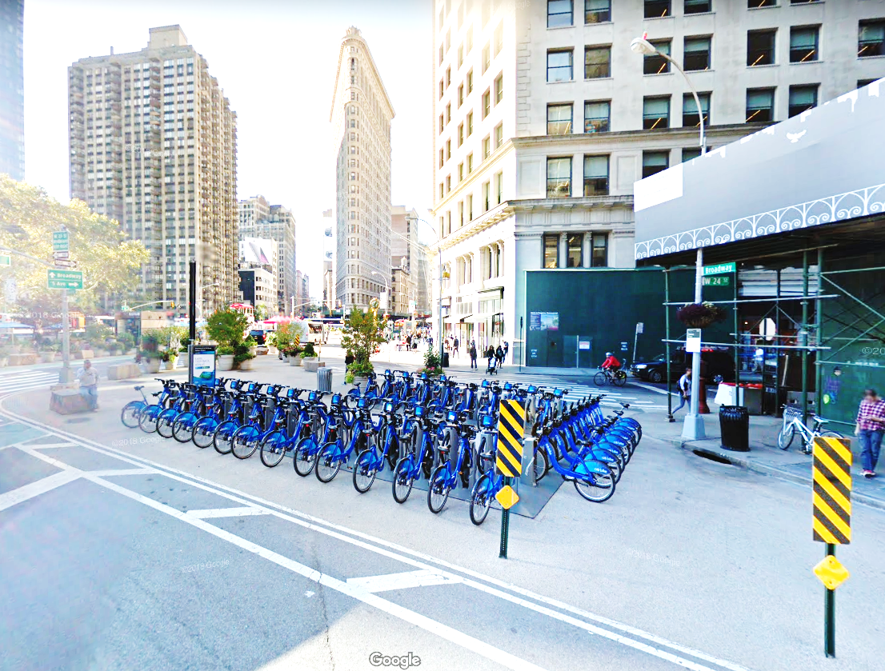

*“Better CitiBike data makes a brighter outlook for NYC”*